Dijkstra’s algorithm
- For understanding the pathfinder algorithm, we must first understand the dijkstra’s algorithm
- Rough pseudocode is given on next page below.

Application of Dijkstra’s algorithm on an example,
Every node has two variables (distance from source, previous node).
Distance from source = infinity. Node A = 0

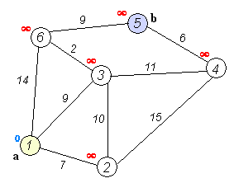
Initial graph

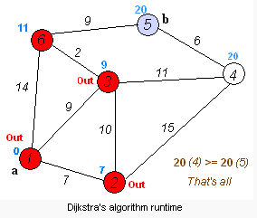

Final graph

1 function Dijkstra(Graph, source):
2 for each vertex v in Graph: // Initializations
3 dist[v] := infinity ; // Unknown distance function from source to v
4 previous[v] := undefined ; // Previous node in optimal path from source
5 end for ;

6 dist[source] := 0 ; // Distance from source to source
7 Q := the set of all nodes in Graph ; // All nodes in graph are unoptimized - thus are in Q

8 while Q is not empty: // The main loop
9 u := vertex in Q with smallest distance in dist[] ;

10 if dist[u] = infinity:
11 break ; // all remaining vertices are inaccessible from source
12 end if ;

13 remove u from Q ; // Terminate here if desired target reached.
14 for each neighbor v of u: // where v has not yet been removed from Q.

15 alt := dist[u] + dist_between(u, v) ;

16 if alt < dist[v]: // Relax (u,v,a)
17 dist[v] := alt ;
18 previous[v] := u ;
19 decrease-key v in Q; // Reorder v in the Queue
20 end if ;
21 end for ;

22 end while ;

23 return dist[] ;
24 end Dijkstra.

- If we are interested in a shortest path between vertices source and target, we can terminate the search at line 13 if u = target

